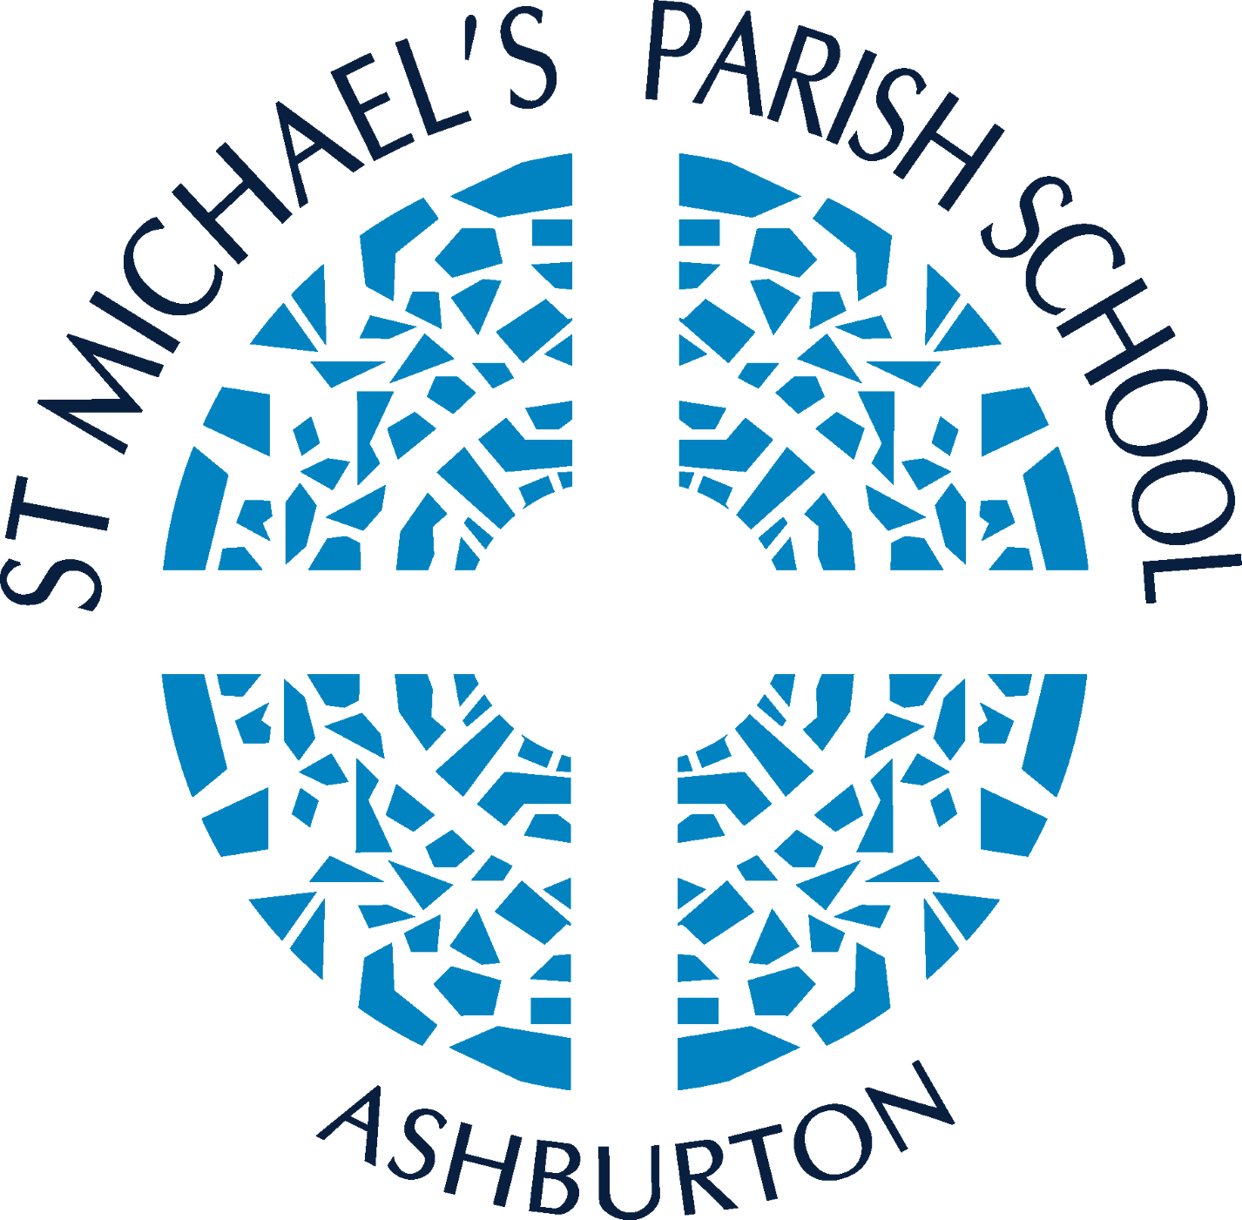
St Michael’s Primary School, Ashburton Child Safety Code of Conduct

Introduction
St Michael’s Primary School, Ashburton is a school which operates with the consent of the Catholic Archbishop of Melbourne and is owned, operated and governed by Melbourne Archdiocese Catholic Schools Ltd (MACS).
Central to the mission of our school is an explicit commitment to providing a safe and supportive environment where the emotional, social, intellectual, spiritual and physical wellbeing of our students is a priority.
All students enrolled at our school have the right to feel safe and be safe. The wellbeing of children in our care will always be our priority, and we do not and will not tolerate child abuse. We aim to create a child-safe and child-friendly environment where children are free to enjoy life to the full without any concern for their safety.

Purpose
This Code of Conduct has a specific focus on promoting child safety and wellbeing in the school environment and safeguarding children and young people at our school against sexual, physical, psychological and emotional abuse or neglect. It is intended to complement other professional and occupational codes.

Scope
All MACS Board members, MACS Board committee members, School Advisory Council members, the principal and all other staff, volunteers, contractors and clergy and those involved in religious ministry at our school are expected to actively contribute to a school culture by respecting the dignity of its members, affirming the Gospel values of love, care for others, compassion and justice. They are required to observe child-safe principles and expectations for appropriate behaviour towards and in the company of children, as noted below. All School Advisory Council members, the principal and all other staff, volunteers, contractors and clergy and those involved in religious ministry must sign and abide by this Code of Conduct.

Acceptable behaviours
All MACS Board members, MACS Board committee members, School Advisory Council members, the principal and all our other staff, volunteers, contractors and clergy at our school are responsible for supporting the safety of children by:
- adhering to the school’s child-safe policy and upholding the school’s statement of commitment to child safety, at all times
- taking all reasonable steps to protect children from abuse
- treating everyone in the school community with respect
- taking into account the needs of all children and students
- listening and responding to the views and concerns of children – particularly if they are telling you that they or another child has been abused or that they are worried about their safety/the safety of another child
- promoting the cultural safety, participation and empowerment of Aboriginal and Torres Strait Islander children (for example, by never questioning an Aboriginal or Torres Strait Islander child’s self-identification)
- promoting the cultural safety, participation and empowerment of children with culturally and linguistically diverse backgrounds (for example, by having a zero-tolerance for discrimination)
- promoting the safety, participation and empowerment of children with a disability (for example, during personal care activities)
- paying particular attention to the needs of students with disability, students from culturally and linguistically diverse backgrounds, students who are unable to live at home, international students and lesbian, gay, bisexual, trans and gender diverse, intersex and queer (LGBTIQ+) students
- ensuring as far as practicable that adults are not alone with a child
- reporting any allegations of child abuse to the school’s leadership (or child safety officer if the school has appointed someone to this role)
- understanding and complying with all reporting obligations as they relate to mandatory reporting and reporting under the Crimes Act 1958 (Vic.)
- understanding and complying with all obligations as they relate to the reportable conduct scheme including reporting allegations of reportable conduct in accordance with the school’s reportable conduct policy
- reporting any child safety concerns to the school’s leadership (or child safety officer if the school has appointed someone to this role)
- ensuring as quickly as possible that the child is safe if an allegation of child abuse is made
- reporting to the Victorian Institute of Teaching (VIT) any charges, committals for trial or convictions in relation to a sexual offence by a registered teacher, or specific allegations or concerns about a registered teacher
- ensuring they comply with any and all applicable professional or occupational codes of conduct.

Unacceptable behaviours
All MACS Board members, MACS Board committee members, School Advisory Council members, the principal and all our other staff, volunteers, contractors and those providing religious ministry at our school must not:
- ignore or disregard any suspected or disclosed child abuse
- develop any special relationships with children that could be seen as favouritism (for example, the offering of gifts or special treatment for specific children)
- exhibit behaviours with children which may be construed as unnecessarily physical (for example, inappropriate sitting on laps)
- put children at risk of abuse (for example, by locking doors)
- initiate unnecessary physical contact with children or do things of a personal nature that a child can do for themselves (for example, toileting or changing clothes)
- engage in open discussions of a mature or adult nature in the presence of children (for example, personal social activities)
- use inappropriate language in the presence of children
- express personal views on cultures, race or sexuality in the presence of children
- discriminate against any child, including because of age, gender, race, culture, vulnerability, sexuality, ethnicity or disability
- work with children while under the influence of alcohol or illegal drugs
- have contact with a child or their family outside school without the school leadership’s or child safety officer’s (if the school has appointed someone to this role) knowledge and/or consent or the school governing authority’s approval (for example, unauthorised after-hours tutoring, private instrumental/other lessons or sport coaching); accidental contact, such as seeing people in the street, is appropriate
- have any online contact with a child (including by social media, email, instant messaging) or their family unless necessary (for example, providing families with eNewsletters or assisting students with their schoolwork)
- use any personal communication channels/devices such as a personal email account
- exchange personal contact details such as phone numbers, social networking sites or email addresses
- where a staff member (including volunteers and those providing religious ministry) have existing relationships outside of school with students and / or families this should be made known to the principal.
- photograph or video a child without the consent of the parents, guardians or carers
- consume illegal drugs at school or at school events in the presence of children
- consume alcohol when responsible for the supervision and care of students.
- consume alcohol at school or at school events in the presence of students with limited exceptions that must be approved by the principal and school advisory council, such as when a school has a VET commercial hospitality venue or at a Year 12 Graduation event where parents / guardians/ carers are present and responsible for their children

Teachers
Teachers are also required to abide by the principles relating to relationships with students as set out in the Victorian Teaching Profession’s Code of Conduct published by the Victorian Institute of Teaching (VIT). These principles include:
- knowing their students well, respecting their individual differences and catering for their individual abilities
- working to create an environment which promotes mutual respect
- modelling and engaging in respectful and impartial language
- protecting students from intimidation, embarrassment, humiliation and harm
- respecting a student’s privacy in sensitive matters
- interacting with students without displaying bias or preference
- not violating or compromising the unique position that a teacher holds of influence and trust in their relationship with students.

Psychologists and school counsellors
In their dealings with students, psychologists and school counsellors should also take into account their professional obligations as set out in a code of ethics or practice to which they are bound, including because of their membership of:
- the Australian Health Practitioner Regulation Agency
- the Australian Counselling Association
- Speech Pathology Australia.

Sports and recreation
Coaches, staff members and volunteers involved in coaching, training or assisting students during sporting and recreation activities should adopt practices that assist children to feel safe and protected, including:
- using positive reinforcement and avoiding abusive, harassing or discriminatory language
- coaching students to be ‘good sports’
- explaining the reason for the contact and asking for the student’s permission if physical contact with a student by a coach or other adult is necessary during a sporting or other recreational activity
- avoiding (where possible) situations where an adult may be alone with a student such as in a dressing or change room, first aid room, dormitory or when the student needs to be transported in a vehicle.

Clergy or other persons involved in religious ministry
Clergy and other persons involved in religious ministry in MACS schools abide by the commitments in the Catholic Archdiocese of Melbourne Statement of Commitment, published by the Professional Standards Unit of the Vicar General’s Office in the Archdiocese of Melbourne, to safeguard children and young people from abuse

Breaches of this code
Where a member of staff is suspected of breaching this Code of Conduct, St Michael’s Primary School, Ashburton may start the process under clause 13 of the Catholic Education Multi-Enterprise Agreement 2022 (CEMEA): Diocese of Ballarat, Diocese of Sandhurst, Archdiocese of Melbourne and Lavalla Catholic College Traralgon for managing employment concerns. This may result in disciplinary consequences.
Where the principal is suspected of breaching this Code of Conduct, the concerned party is advised to contact the MACS Regional General Manager.
Where any other member of the school community, including volunteers and contractors, is suspected of breaching this code, the school is to take appropriate action, including (if applicable) in accordance with the PROTECT: Identifying and Responding to All Forms of Abuse in Victorian Schools policy.
In appropriate cases, a breach may be referred to Victoria Police and/or a regulatory body, such as the VIT.

Related policies and documents

Related MACS policies and documents
Child Safety and Wellbeing Policy and Procedures
PROTECT: Identifying and Responding to Abuse – Reporting Obligations Policy and associated procedures
Reportable Conduct Policy

Legislation and standards
Crimes Act 1958 (Vic.)
Ministerial Order 1359: Implementing the Child Safe Standards- Managing the risk of Child Abuse in Schools and School Boarding Premises
Catholic Education Multi-Enterprise Agreement 2022 (CEMEA): Diocese of Ballarat, Diocese of Sandhurst, Archdiocese of Melbourne and Lavalla Catholic College Traralgon

Policy information table
Responsible director | Director, Learning and Regional Services
Policy owner | General Manager, Student Wellbeing
Approving Authority | Executive Director
Approval date | 21 November 2023
Preliminary review by | NA
Major review by | March 2025

Declaration

I, __________________________________________________________________________,
confirm I have been provided with a copy of the above Code of Conduct and will abide by it.

Signed: ____________________________________________________________________
Date: ______________________________________________________________________

