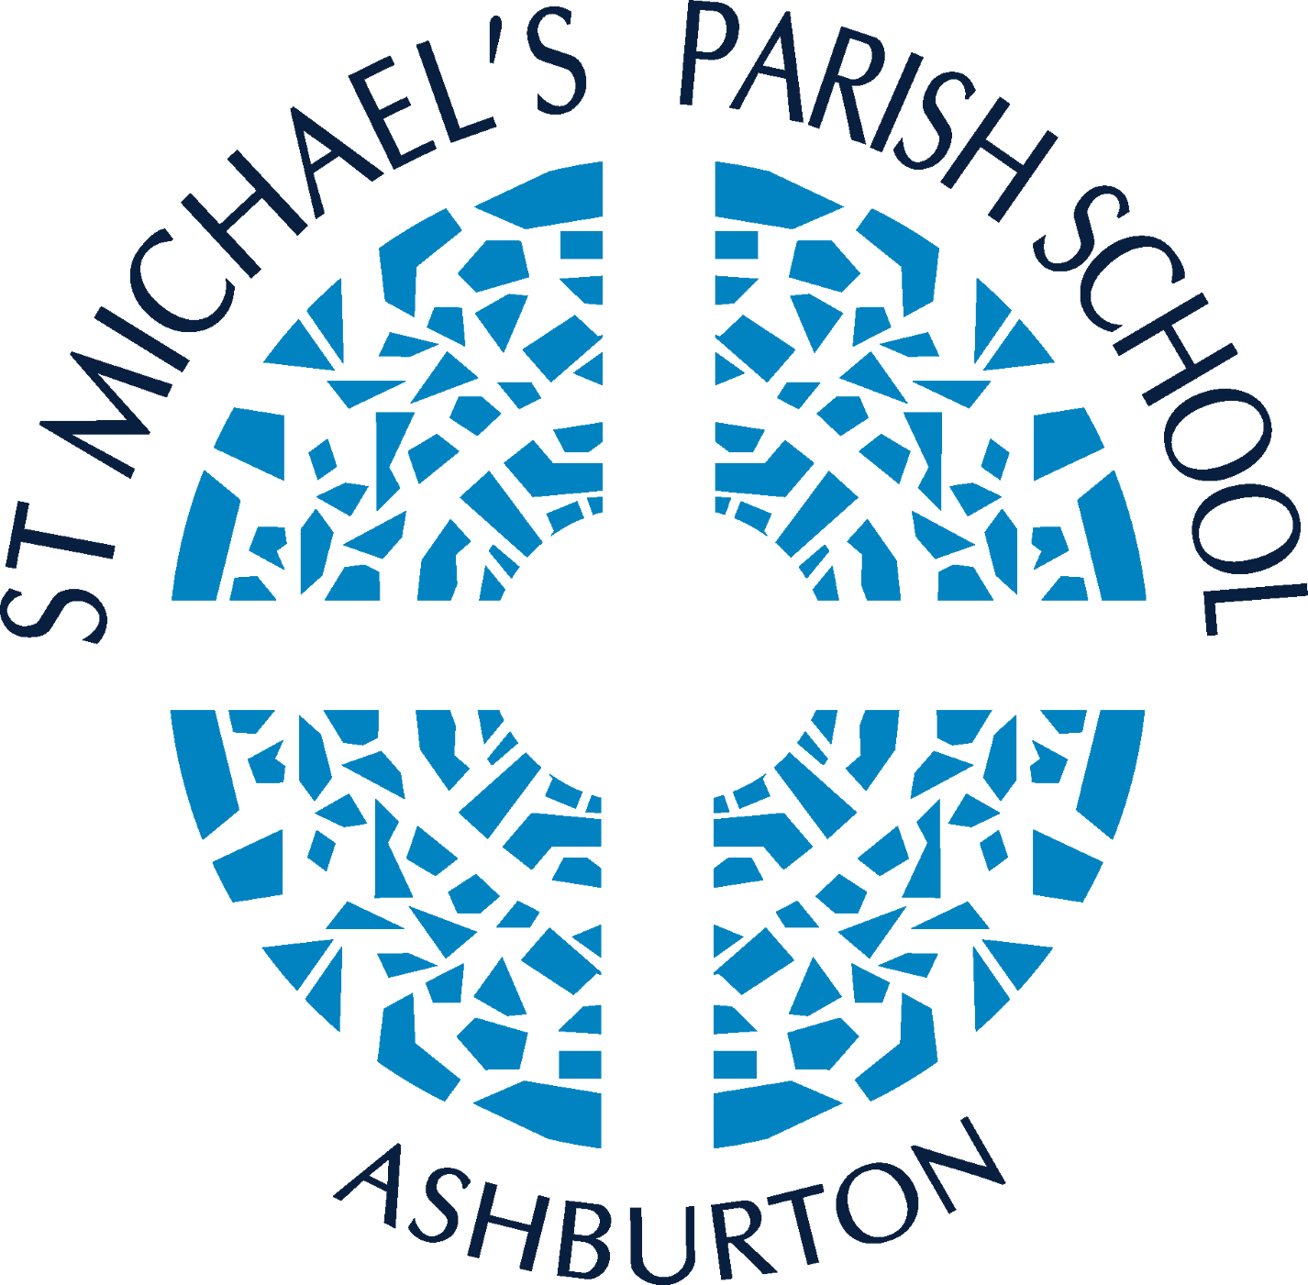
St Michael’s Primary School, Ashburton Child Safety and Wellbeing Policy

Introduction
St Michael’s Primary School, Ashburton is a school which operates with the consent of the Catholic Archbishop of Melbourne and is owned, operated and governed by Melbourne Archdiocese Catholic Schools Ltd (MACS).
At our school, we hold the care, safety and wellbeing of children and young people as a central and fundamental responsibility of our school. Our commitment is drawn from and inherent to the teaching and mission of Jesus Christ, with love, justice and the sanctity of each human person at the heart of the gospel (CECV Commitment Statement to Child Safety).
The person of each individual human being, in his or her material and spiritual needs, is at the heart of Christ’s teaching: this is why the promotion of the human person is the goal of the Catholic school (The Catholic School on the Threshold of the Third Millennium, n. 9).
Our Vision at St Michael’s School is “a safe community of animated learners, enlightened by faith in God.”

Purpose
To demonstrate the strong commitment of our school to the care, safety and wellbeing of all students at our school. It provides an outline of the policies, procedures, actions and strategies that will be implemented to ensure that a child safe culture is championed and modelled at all levels of the school, to keep students safe from harm, including all forms of abuse in our school environment, on campus, online and in other locations provided by the school.
This Policy takes into account relevant legislative requirements within the state of Victoria, including the specific requirements of the Child Safe Standards as set out in Ministerial Order No. 1359: Implementing the Child Safe Standards – Managing the Risk of Child Abuse in Schools and School Boarding Premises.

Scope
Everyone employed or volunteering at our school has a responsibility to understand the important and specific role they play individually and collectively to ensure a child safe culture in which the wellbeing and safety of all students is at the forefront of all they do and every decision they make (CECV Statement of Commitment to Child Safety).
This policy applies to all school staff, volunteers and contractors whether or not they work in direct contact with students. It also applies to school council members where indicated.
The policy applies to all physical and online school environments used by students during or outside of school hours, including other locations provided by our school for a student’s use (for example, a school camp) and those provided through third-party providers.
This policy should be read together with our other child safety and wellbeing policies, procedures, and codes including:
- PROTECT: Identifying and Responding to Abuse – Reporting Obligations Policy and associated procedures
- Child Safety Code of Conduct
- Engaging Families in Child Safety Policy
- Reportable Conduct Policy.
Please refer to the related school policies section below for further information.
The school has allocated roles and responsibilities for child safety and wellbeing as follows:
St Michael’s Child Safety Champions:
Mrs Annie Herbison (Principal)
Mrs Eloise Ellis (Deputy Principal)
Mrs Charlotte Allan (Student Wellbeing Leader)

Principles
Catholic schools have a moral, legal and mission-driven responsibility to create nurturing school environments where children and young people are respected, have agency, their voices are heard, and they are safe and feel safe (CECV Statement of Commitment to Child Safety).
The following principles underpin our commitment to child safety and wellbeing at our school:
- All students deserve, as a fundamental right, safety and protection from all forms of abuse and neglect.
- Our school staff work in partnership with families and the community to ensure that they are engaged in decision-making processes, particularly those that have an impact on child safety and wellbeing and protection.
- All students have the right to a thorough and systematic education in all aspects of personal safety, in partnership with their parents/guardians/carers.
- All adults in our school, including teaching and non-teaching staff, clergy, volunteers and contractors, have a responsibility to:
- care for children and young people
- positively promote their wellbeing
- identify and mitigate risks related to child safety and wellbeing in the school environment
- protect them from any kind of harm or abuse, and
- encourage and support children to express their culture and enjoy their cultural rights.
- Our school community is committed to equity and inclusion and recognising and respecting the diverse needs of all children.
- All adults in our school will take all reasonable measures to prevent child abuse and harm resulting from discrimination based on disability, race, ethnicity, religion, sex, intersex status, gender identity or sexual orientation.
- All members of the school community (including students and their families) are kept informed of child safety and wellbeing matters (where appropriate) and are involved in promoting child safety and wellbeing.
- Staff, clergy, volunteers, contractors, parents and students should feel free to raise concerns about child safety and wellbeing, knowing these will be taken seriously by school leadership.
- Appropriate confidentiality is maintained, with information being provided to those who have a right or a need to be informed, either legally (including under legislated information sharing schemes being Child Information Sharing Scheme (CISS) or Family Violence Information Sharing Scheme (FVISS)) or pastorally

Policy
Policy commitments
All students enrolled at our school have the right to feel safe and be safe. The safety and wellbeing of children in our care will always be our first priority and we do not and will not tolerate child abuse. We aim to create a child-safe and child-friendly environment where children are free to enjoy life to the full without any concern for their safety. There is particular attention paid to the most vulnerable children, including Aboriginal and Torres Strait Islander children, children from culturally and/or linguistically diverse backgrounds, children with a disability, children who are unable to live at home, international students, and LGBTIQ+ students.

Our commitment to our students
- We commit to the safety and wellbeing of all children and young people enrolled in our school.
- We commit to providing children and young people with positive and nurturing experiences.
- We commit to encouraging and actively supporting Aboriginal and Torres Strait Islander children to express their culture and enjoy their cultural rights
- We commit to paying particular attention to the needs of students with disability, students from culturally and linguistically diverse backgrounds, students who are unable to live at home, international students, and lesbian, gay, bisexual, trans and gender diverse, intersex and queer (LGBTIQ+) students
- We commit to listening to children and young people and empowering them by ensuring that they understand their rights (including to safety, information and participation), and by taking their views seriously and addressing any concerns that they raise with us.
- We commit to taking action to ensure that children and young people are protected from abuse or harm.
- We commit to ensuring that the needs of all children and young people enrolled in our school are met, including those who are most vulnerable.
- We commit to recognising the importance of friendships and to encouraging support from peers, to help children and young people feel safe and less isolated.
- We commit to developing a culture that facilitates and provides opportunities for student participation, and that strengthens the confidence and engagement of children and young people by being responsive to their input.
- We commit to teaching children and young people the necessary skills and knowledge to understand and maintain their personal safety and wellbeing.
- We commit to empowering children and educating them about their rights (including to safety, information and participation), how to raise concerns, how to maintain their personal safety and wellbeing, and how to support the safety and wellbeing of other children.
- We commit to seeking input and feedback from students regarding the creation of a safe school environment.

Our commitment to parents, guardians and carers
- We recognise that families are the first and ongoing educators of their children.
- We commit to communicating honestly and openly with parents, guardians and carers about the wellbeing and safety of their children.
- We commit to engaging with, and listening to, the views of parents, guardians and carers about our child safety and wellbeing practice, policies and procedures and include them in decision-making practices where applicable.
- We commit to transparency in our decision-making with parents, guardians and carers where it will not compromise the safety of children or young people.
- We commit to open engagement and communication with parents, guardians and carers about our child safe approach and our operations and governance related to child safety and wellbeing.
- We commit to ensuring that relevant information relating to child safety and wellbeing is accessible to parents, guardians and carers.
- We commit to acknowledging the cultural diversity of students and families, and being sensitive to how this may impact on student safety issues.
- We commit to continuously reviewing and improving our systems to protect children from abuse.

Our commitment to our school staff (school employees, volunteers, contractors and clergy)
- We commit to providing all our school staff with the necessary support to enable them to fulfil their roles, and to ensure that staff are attuned to signs of harm and are able to facilitate child-friendly ways for children and students to express their views, participate in decision-making and raise their concerns. This will include regular and appropriate learning opportunities.
- We commit to providing regular opportunities to clarify and confirm policy and procedures in relation to child safety and wellbeing, and young people’s protection and wellbeing. This will include annual training in the principles and intent of the Child Safety and Wellbeing Policy and Child Safety Code of Conduct, and staff responsibilities to report concerns.
- We commit to listening to all concerns voiced by our school staff, clergy, volunteers and contractors about keeping children and young people safe from harm.
- We commit to providing opportunities for our school employees, volunteers, contractors and clergy to receive formal debriefing and counselling arising from incidents of the abuse of a child or young person.

Privacy and information sharing
Our school is bound by the Australian Privacy Principles contained in the Australian Privacy Act 1988 (Cth) and the Health Privacy Principles set out in the Health Records Act 2001 (Vic).
Our Privacy Policy sets out the types of information that we collect about:
- students and prospective students, and their parents, guardians and carers
- job applicants, staff members, volunteers and contractors
- other people who come into contact with MACS.
It also sets out how and why our school collects, holds, uses, discloses, secures and stores the information.
Our school is a prescribed Information Sharing Entities (ISE). This means that we are able to collect and share confidential information with other ISEs to promote child wellbeing or safety under the Child Information Sharing Scheme (CISS) or Family Violence information Sharing Scheme (FVISS).

Recordkeeping
Our school creates full and accurate records of school activities and decisions relating to the safety and wellbeing of students.
These records are maintained as per our Child Safety and Record Keeping Policy and the child safety and wellbeing standards set by the Public Records Office of Victoria. These records are kept secure and protected from unauthorised access, amendment, misuse, disclosure, damage, deterioration, loss or destruction.

Procedures
The procedures for implementing, modelling and monitoring a child safe culture in schools are detailed further in the Child Safety Code of Conduct

Definitions

Child
Means a child or young person who is under the age of 18 years.
Child abuse
Child abuse includes:
- any act committed against a Child involving:
- a sexual offence
- an offence under section 49B(2) of the Crimes Act 1958 (grooming)
- the infliction, on a Child, of:
  - physical violence
  - serious emotional or psychological harm
- serious neglect of a Child.
Child safety
Child safety encompasses matters related to protecting all children from child abuse, managing the risk of child abuse, providing support to a child at risk of child abuse, and responding to suspicions, incidents, disclosures or allegations of child abuse (Ministerial Order No. 1359).
Child neglect
Child neglect includes a failure to provide the child with an adequate standard of nutrition, medical care, clothing, shelter or supervision to the extent that the health and physical development of the child is significantly impaired or placed at serious risk (PROTECT: Identifying and responding to all forms of abuse in Victorian schools).
Child physical abuse
Child physical abuse generally consists of any non-accidental infliction of physical violence on a child by any person (PROTECT: Identifying and responding to all forms of abuse in Victorian schools).
Child sexual abuse
Child sexual abuse is where a person uses power or authority over a child to involve them in sexual activity. It can include a wide range of sexual activity and does not always involve physical contact or force (PROTECT: Identifying and responding to all forms of abuse in Victorian schools).
Emotional child abuse
Occurs when a child is repeatedly rejected, isolated or frightened by threats, or by witnessing family violence (PROTECT: Identifying and responding to all forms of abuse in Victorian schools).
Grooming
Grooming refers to predatory conduct engaged in by a person to prepare a child for sexual activity at a later date. It can include communication and/or attempting to befriend or establish a relationship or other emotional connection with the child or their parent/carer (PROTECT: Identifying and responding to all forms of abuse in Victorian schools).
Mandatory reporting
The legal requirement under the Children, Youth and Families Act 2005 (Vic.) to protect children from harm relating to physical and sexual abuse. The Principal, registered teachers and early childhood teachers, school counsellors, religious clergy, medical practitioners and nurses at a school are mandatory reporters under this Act (PROTECT: Identifying and responding to all forms of abuse in Victorian schools).
Reasonable belief – mandatory reporting
When school staff are concerned about the safety and wellbeing of a child or young person, they must assess that concern to determine if a report should be made to the relevant agency. This process of considering all relevant information and observations is known as forming a reasonable belief. A ‘reasonable belief’ or a ‘belief on reasonable grounds’ is not the same as having proof, but is more than mere rumour or speculation. A reasonable belief is formed if a reasonable person in the same position would have formed the belief on the same grounds (PROTECT: Identifying and responding to all forms of abuse in Victorian schools).
Reasonable belief – reportable conduct scheme
When a person has a reasonable belief that a worker/volunteer has committed reportable conduct or misconduct that may involve reportable conduct. A reasonable belief is more than suspicion and there must be some objective basis for the belief. It does not necessitate proof or require certainty.
NOTE: the difference between the reasonable belief definitions under mandatory reporting and the reportable conduct scheme is the category of persons who are required to, or can, form the reasonable belief which forms the basis for a report.
Reportable conduct
Reportable conduct for the purposes of the Reportable Conduct Scheme is:
- a sexual offence committed against, with or in the presence of, a child, whether or not a criminal proceeding in relation to the offence has been commenced or concluded
- sexual misconduct, committed against, with or in the presence of, a child
- physical violence committed against, with or in the presence of, a child
- any behaviour that causes significant emotional or psychological harm to a child
- significant neglect of a child as defined in the Child Wellbeing and Safety Act 2005 (Vic).
- significant neglect.
School environment
Means any of the following physical, online or virtual places used during or outside school/service hours:
- a campus of the school
- a campus of a MACSEYE service
- online or virtual school/service environments made available or authorised by MACS or a MACS school or MACSEYE service for use by a child or student (including email, intranet systems, software, applications, collaboration tools and online services)
- other locations provided by the school/service or through a third-party provider for a child or student to use including, but not limited to, locations used for camps, approved homestay accommodation, delivery of education and training, sporting events, excursions, competitions and other events) (Ministerial Order No. 1359).
School staff
Means an individual working in a school environment who is:
- directly engaged or employed by a school governing authority
- a contracted service provider engaged by MACS (whether or not a body corporate or any other person is an intermediary) engaged to perform child-related work for our school
- a minister of religion, a religious leader or an employee or officer of a religious body associated with MACS (Ministerial Order No. 1359).

Volunteer
A person who performs work without remuneration or reward for MACS, a MACS school or MACSEYE service in the school/service environment.

Related policies and documents

Supporting documents
Child Safety and Wellbeing Procedures

Related MACS policies and documents
Child Safety Code of Conduct
Engaging Families in Child Safety Policy
PROTECT: Identifying and Responding to Abuse – Reporting obligations
Recruitment Policy
Reportable Conduct Policy
Supervision Policy
Suspension. Negotiated Transfer and Expulsion Policy

Resources
CECV Guidelines on the Employment of Staff in Catholic Schools
CECV Guidelines on the Engagement of Volunteers in Catholic Schools
CECV Guidelines on the Engagement of Contractors in Catholic Schools
CECV NDIS/External Providers: Guidelines for Schools
CECV Positive Behaviour Guidelines

Legislation and standards
Ministerial Order 1359: Implementing the Child Safe Standards – Managing the Risk of Child Abuse in Schools and School Boarding Premises
Children, Youth and Families Act 2005 (Vic.)
Child Wellbeing and Safety Act 2005 (Vic.)
Worker Screening Act 2020 (Vic.)
Education and Training Reform Act 2006 (Vic.)
Education and Training Reform Regulations 2017 (Vic.)
Equal Opportunity Act 2010 (Vic.)
Privacy Act 1988 (Cth)
Public Records Act 1973 (Vic)
Crimes Act 1958 (Vic.) – including three criminal offences under this Act:
- Failure to disclose offence: Any adult who forms a reasonable belief that a sexual offence has been committed by an adult against a child under 16 has an obligation to report that information to police. Failure to disclose the information to police is a criminal offence.
- Failure to protect offence: This offence will apply where there is a substantial risk that a child under the age of 16 under the care, supervision or authority of a relevant organisation will become a victim of a sexual offence committed by an adult associated with that organisation. A person in a position of authority in the organisation will commit the offence if they know of the risk of abuse and have the power or responsibility to reduce or remove the risk, but negligently fail to do so.
- Grooming offence: This offence targets predatory conduct designed to facilitate later sexual activity with a child. Grooming can be conducted in person or online, for example via interaction through social media, web forums and emails.

Policy information
Responsible director | Director, Learning and Regional Services
Policy owner | General Manager, Student Wellbeing
Approving authority | MACS Board
Assigned board committee | Child Safety and Risk Management
Approval date | 21 November 2023
Risk Rating | Extreme
Preliminary review by | NA
Major review by | March 2025
Publication | Gabriel, CEVN, School website

POLICY DATABASE INFORMATION
Assigned framework | Child Safety and Wellbeing
Supporting documents | See list above
Superseded documents | Child Safety and Wellbeing Policy – v2.0 – 2022  School Child Safety Policy – v1.0 – 2021
New policy

